JULES Set–up document for JULES Project: ADD-TREES

Source: <https://code.metoffice.gov.uk/trac/jules/wiki/RoseJULESonJASMIN>

**1. To get access to JULES code.**

- Use  [JULES code acces link](http://jules-lsm.github.io/access_req/JULES_access.html). You will get the following screen, fill in the information, accept *Terms and Conditions* and click on the *Send request* button. If you have issues, read carefully the information in the rectangle of the image below.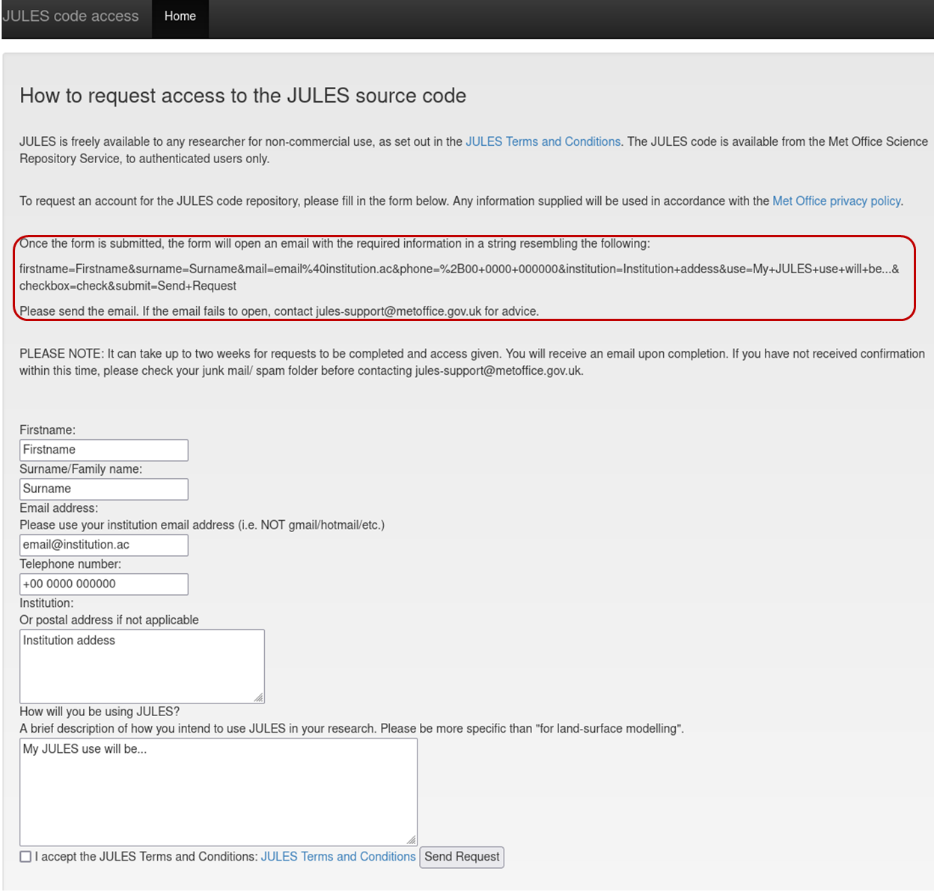

Once you get access to the JULES code you will get Met Office Science Repository Service (mosrs) password advice at [Changing your MOSRS password](https://code.metoffice.gov.uk/trac/home/wiki/AuthenticationCaching/GnomeKeyring#ChangingyourScienceRepositoryServicepassword).

**2. To get a JASMIN account.**

[Apply for a new JASMIN account](https://accounts.jasmin.ac.uk/)

Sign up for a JASMIN login account: [Sign in with a JASMIN account](https://accounts.jasmin.ac.uk/account/login/?next=/account/profile/)

Create an SSH key pair: [ssh-key-linux](https://help.jasmin.ac.uk/article/185-generate-ssh-key-pair)

Upload your public key, sign in your JASMIN account. On your JASMIN Profile there will be a blue ‘Update Key’ button, where you can add your public key. [registering your ssh key](https://accounts.jasmin.ac.uk/account/profile/)

Request access to the *uknetzero* Group Workspace, on your JASMIN Profile click on the green ‘My Services’ button where you can request access to the workspace.

In you have any problems please see [more information](https://help.jasmin.ac.uk/article/189-get-started-with-jasmin) and [login problems](https://help.jasmin.ac.uk/article/848-login-problems), or send an e-mail to the JASMIN Helpdesk ([suppor@jasmin.ac.uk](mailto:suppor@jasmin.ac.uk)).

**3. Software.**

. Install the following software in advance depending on your Operative System, you will need one of these to be able to connect to the JASMIN-HPC. 

* For Windows: install [MobaXterm](https://eur03.safelinks.protection.outlook.com/?url=https%3A%2F%2Fmobaxterm.mobatek.net%2F&data=02%7C01%7CM.C.Duran-Rojas%40exeter.ac.uk%7C2e5cd1a364864b88f40b08d756e01b2c%7C912a5d77fb984eeeaf321334d8f04a53%7C0%7C0%7C637073392829865621&sdata=Rsg8rNHvqHsO6k30xYNX7ztNv%2FecNl045x%2Fc49eJLvo%3D&reserved=0) and configure your computer for MobaXterm following the instructions in [this document](https://universityofexeteruk-my.sharepoint.com/:w:/r/personal/m_c_duran-rojas_exeter_ac_uk/Documents/MobaXTerm_setup.docx?d=w95145214dbbc4bf0b1249d1283434052&csf=1&web=1&e=3bjUUu) and instructions in section 4.
* For Macintosh: install [XQuartz](https://eur03.safelinks.protection.outlook.com/?url=https%3A%2F%2Fwww.xquartz.org%2F&data=02%7C01%7CM.C.Duran-Rojas%40exeter.ac.uk%7C2e5cd1a364864b88f40b08d756e01b2c%7C912a5d77fb984eeeaf321334d8f04a53%7C0%7C0%7C637073392829865621&sdata=vMhdjQ%2B2Amh7YGV%2BrWDJjdh8gm6KRf2pjMrbl90aqUM%3D&reserved=0).
* For Linux follow the instructions described in section 4.

4. Configuration of your account.

1. Configure your SSH config file to use the login-01.jasmin server to tunnel through to cylc2.jasmin where the suite will run.
2. Edit your ~/.ssh/config file as follows (changing the <*jasmin_userid*> to your own userid).
3. Create the /.ssh folder on your terminal using mkdir ~/.ssh
4. Edit the config file using vim ~/.ssh/config
5. Add the following lines to the file:

Host *   
     ServerAliveInterval 30   
   
Host jlogin1   
    Hostname login-01.jasmin.ac.uk   
    User *jasmin_userid*   
    ForwardAgent yes   
   
Host xfer-vm-0?   
    Hostname %h.jasmin.ac.uk   
    User *jasmin_userid*   
    ForwardAgent yes   
   
Host sci-vm-0? sci-ph-0? cylc2   
    HostName %h.jasmin.ac.uk   
    User *jasmin_userid*   
    ForwardAgent yes   
    ProxyCommand ssh -Y jlogin1 -W %h:%p   
    ProxyJump *jasmin_userid*@jlogin1 

1. Start an ssh-agent session on the terminal type:

eval $(ssh-agent -s); ssh-add ~/.ssh/id_rsa_jasmin

The ~/.ssh/id_rsa_jasmin  file is your your jasmin ssh private key file and type your passphrase. 

1. Logging into JASMIN with the following command.

ssh -A -X [kday002@login-01.jasmin.ac.uk](mailto:kday002@login-01.jasmin.ac.uk)

Make sure to use the ‘-X’ option, the X-forwarding for graphical applications when log in, if not, it might cause a mosrs (Met Office Science Repository Service) issue. If it works, you will find yourself logged into login-01.jasmin.

1. Modify the following configuration files on your jasmin account on the cylc2.jasmin server

Ensure that you login to cylc2.jasmin - do not try from other systems since they do not have the required setup. If you try instead to submit Cylc jobs from the sci*.jasmin servers, the Cylc8 GUI might not appear. If you want to do other (interactive) processing besides running Rose/Cylc, then it is better to use the sci*.jasmin servers. The old path of /apps/contrib/metomi/ has been changed to /apps/jasmin/metomi/ in several places below.

1. Edit your ~/.bash_profile by adding the following lines to tha top of the file.

# Get the aliases and functions   
if [ -f ~/.bashrc ]; then   
        . ~/.bashrc   
fi   
   
# Provide access to FCM, Rose and Cylc   
PATH=$PATH:/apps/jasmin/metomi/bin   
   
# User specific environment and startup programs   
export PATH=$PATH:$HOME/bin   
HOST=$(hostname)   
   
if [[ $HOST = "cylc2.jasmin.ac.uk" ]]; then   
# Rose/cylc on  cylc2.jasmin node   
export PATH=$PATH:/apps/jasmin/metomi/bin   
fi 

1. Add the following at the end of your ~/.bashrc file:

[[ $- != *i* ]] && return # Stop here if not running interactively   
[[ $(hostname) = "cylc2.jasmin.ac.uk" ]] && .mosrs-setup-gpg-agent   
# Enable bash completion for Rose commands   
[[ -f /apps/jasmin/metomi/rose/etc/rose-bash-completion ]] && . /apps/jasmin/metomi/rose/etc/rose-bash-completion 

Now, whenever you login to cylc2.jasmin you should be prompted for your Met Office Science Repository Service password. Just press return if you do not want access to the repositories and you should not be prompted again during that login session.

1. A further set-up for JASMIN and MOSRS requires an update to your ~/.subversion/servers file.
2. Create the folder subversion using  mkdir ~/.subversion
3. Edit the file ~/.subversion/servers, using vi ~/.subversion/servers
4. Add the following lines using your metoffice username in *myusername*.

[groups]   
metofficesharedrepos = code*.metoffice.gov.uk   
   
[metofficesharedrepos]   
# Specify your Science Repository Service username here   
username = *myusername*   
store-plaintext-passwords = no 

1. Open the ~/.subversion/config with vi ~/.subversion/config and comment (by adding the # symbol) any lines starting with:

#password-stores =



a. Create the folder metomi using  mkdir ~/.metomi.

b. Add the following lines to the rose.conf file using vi ~/.metomi/rose.conf (change myusername word for your MOSRS-username):

[rosie-id]   
prefix-default=u   
prefix-location.u=https://code.metoffice.gov.uk/svn/roses-u   
prefix-username.u=myusername   
#username is all in lower case   
   
prefix-ws.u=https://code.metoffice.gov.uk/rosie/u   
   
[rose-stem]   
automatic-options=SITE=jasmin 

1. This can be checked by running:

rose config

1. a. Create the following folder mkdir ~/.metomi/fcm.

b. Open the file keyword.cfg using vi ~/.metomi/fcm/keyword.cfg and add the lines:

location{primary, type:svn}[jules.x] = <https://code.metoffice.gov.uk/svn/jules/main>   
browser.loc-tmpl[jules.x] = [https://code.metoffice.gov.uk/trac/{1}/intertrac/source:/{2}{3](https://code.metoffice.gov.uk/trac/%7b1%7d/intertrac/source:/%7b2%7d%7b3)}   
browser.comp-pat[jules.x] = (?msx-i:\A // [^/]+ /svn/ ([^/]+) /*(.*) \z)   
   
location{primary, type:svn}[jules.xm] = <https://code.metoffice.gov.uk/svn/jules/main>   
browser.loc-tmpl[jules.xm] = [https://code.metoffice.gov.uk/trac/{1}/intertrac/source:/{2}{3](https://code.metoffice.gov.uk/trac/%7b1%7d/intertrac/source:/%7b2%7d%7b3)}   
browser.comp-pat[jules.xm] = (?msx-i:\A // [^/]+ /svn/ ([^/]+) /*(.*) \z)   
   
location{primary, type:svn}[jules_doc.x] = <https://code.metoffice.gov.uk/svn/jules/doc>   
browser.loc-tmpl[jules_doc.x] = [https://code.metoffice.gov.uk/trac/{1}/intertrac/source:/{2}{3](https://code.metoffice.gov.uk/trac/%7b1%7d/intertrac/source:/%7b2%7d%7b3)}   
browser.comp-pat[jules_doc.x] = (?msx-i:\A // [^/]+ /svn/ ([^/]+) /*(.*) \z) 

1. Test if the connection to cylc2.jasmin works (from login-01.jasmin):

ssh -AX [kday002@cylc2.jasmin.ac.uk](mailto:kday002@cylc2.jasmin.ac.uk)

xterm &

Now an xterm window will appear, which you can close if you want. Exit of the cylc2.jasmin server using logout or control-D

1. Test that the direct connection to cylc2.jasmin works (from your own laptop or desktop machine) using

ssh -AX [kday002@cylc2.jasmin.ac.uk](mailto:kday002@cylc2.jasmin.ac.uk)

then, login directly from your own machine to cylc2.jasmin

You should only have to enter your MOSRS password when prompted; there is no login password for cylc2.jasmin

xterm &

Now an xterm window will appear, which you can close if you want.

Exit # logout of the cylc2.jasmin server

1. To run JULES you will need a suite-ID wich will contains all the parameters to run the model. Contact your tutor to get access to a suite-ID.

**5. FAIR USE POLICY**

We ask that users of these instructions and suite-ID follow the guidelines for fair use.

The guidelines apply to research applications that result in publication (journal articles, thesis, technical reports).

The creators of these instructions and the suite-ID are Carolina Duran Rojas and Mingda Yuan (Ming Deyu, Dany Williamson and Anna Harper).

Offer co-authorship to the owners and contributors to this document if they have provided technical or scientific support to the analysis.

Let the authors of this document and the suite-ID of the plans to use the suite for publication at the early stages, so we can provide updates to run the model o JASMIN.